US ^{How To:}
Use Cloud Cam
UniqueSchools
Cloud Cam is a system which enables staff to take photos of students and school related items without the images ever being stored on their personal devices.
The images are automatically stored on a cloud based server and only publishable through the app.
Open your Communicators App and go to Cloud Cam.
Here you will see all the pre-loaded Cloud Cam images and you can also take a new image from here.
Click on the camera icon on the bottom right and this will open the camera.
Take your photos. Once you have finished click on the tick button.
Decide if you want to SYNC or DELETE the images you have taken. You must SYNC any images you want to use or keep.
Once you have synced the images they can be used in future posts and/or galleries.
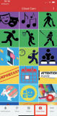
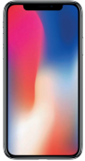Open camera 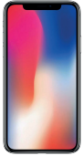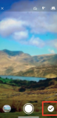Store photos 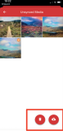
Sync or delete images

